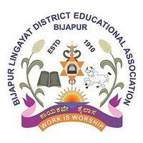

BLDE Association’s
New Arts College, Tikota
Dist. Vijayapura – Karnataka State
(Accredited with ‘B’ Grade by NAAC)
EST.1969
Affiliated to Rani Channamma University, Belagavi
Email: nac_tikota07@yahoo.co.in Website: www.bldeanacct.ac.in
Phone No: 08352-231932 Mobile No: 9448972457

REPORT OF EXTENSION ACTIVITIES
(2016-17 TO 2020-21)
Public awareness rally on Population explosion was organized at Tikota on 20-07-2016 on the occasion of World Population Day.
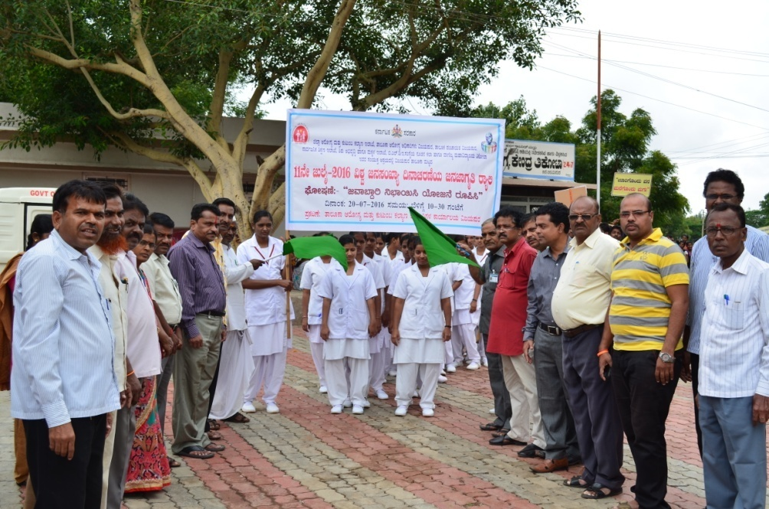

Campus cleaning activity was held on 27-07-2016 on the occasion of death anniversary of Shri B.M.Patil.
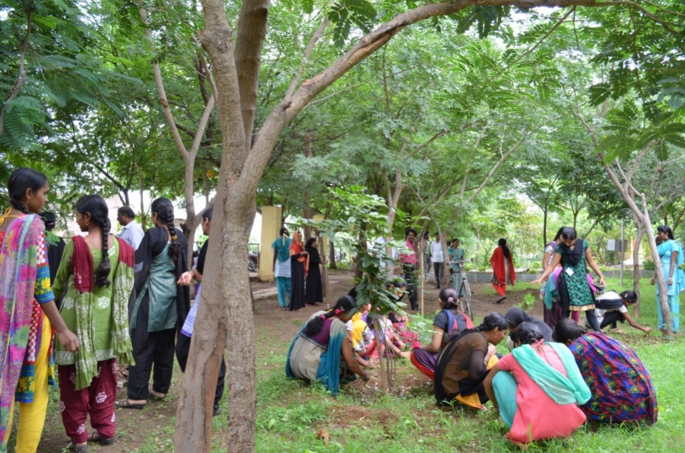

Public Exhibition of Geographical and Historical items was organized in the college by the Departments of Geography and History on 24/08/2016.
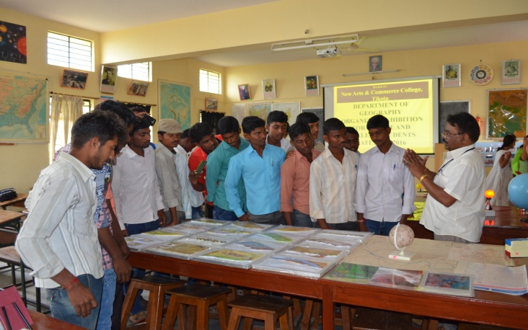

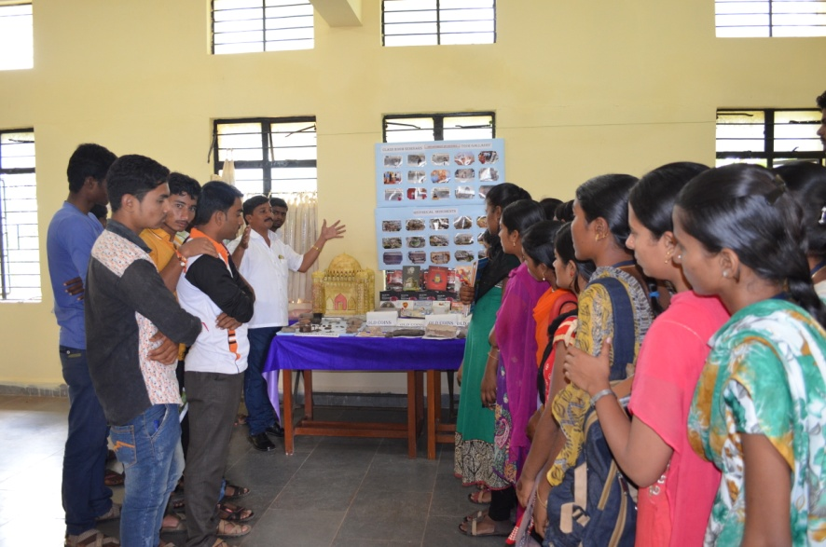

Youth Leadership and Community Development Training
Taluka level ‘Youth Leadership and Community Development Training’ was held in the College on 21-01-2017 in collaboration of N.S.S Units, Nehru Youth Centre, Field Promotion Directorate, Central Govt. Scouts and Rovers of the college also participated in the College.

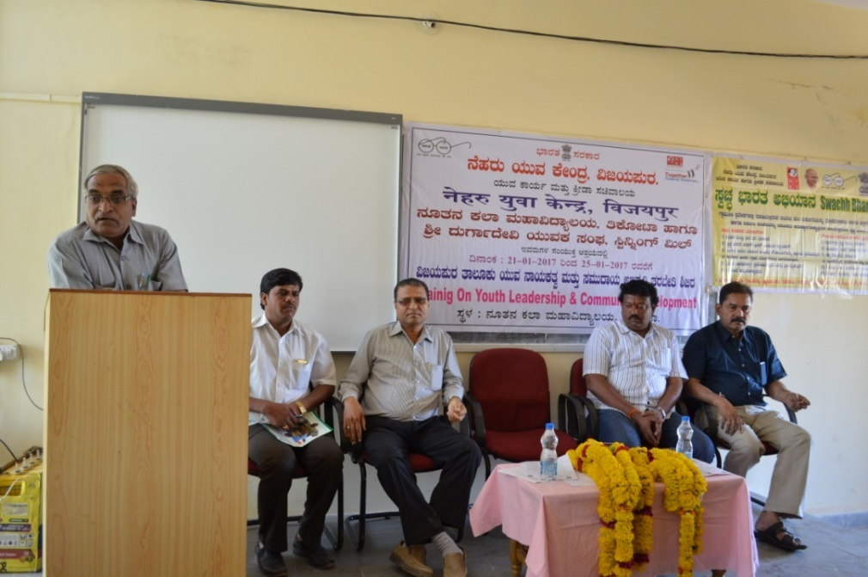
BLOOD DONATION CAMP
Blood donation camp was organized in the College on 08-03-2017 in collaboration of N.S.S Units and Youth Red Cross and B.L.D.E.A’s Nursing College, Vijayapur. In total of 17 students donated blood voluntarily.
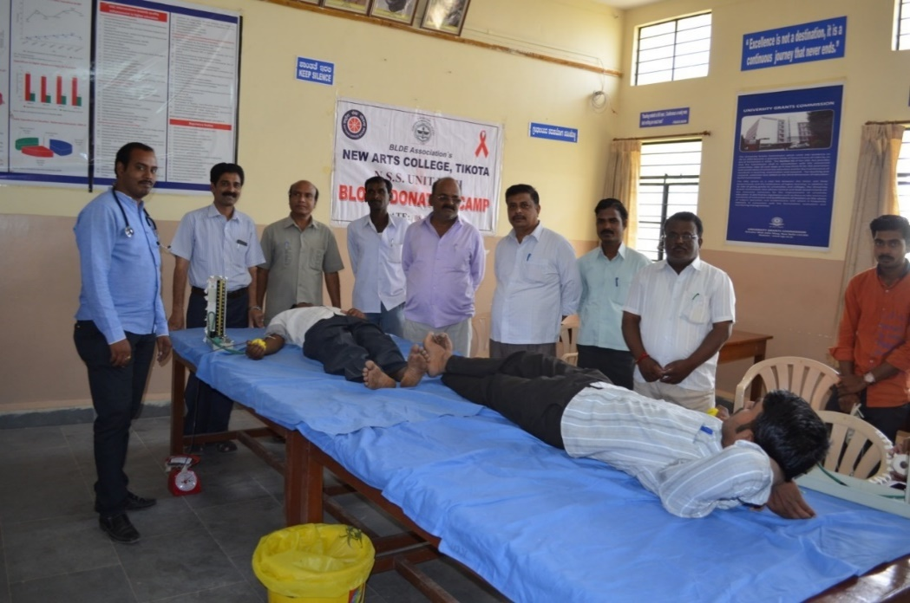

N.S.S SPECIAL CAMP
The NSS unit I and II have conducted the Special Camp in the adopted village Rampur from
19 -1-2017 to 31-1-2017. The program was inaugurated at 4 p.m. by the Chief Guest Shri Mallikarjun Onti, S.D.M.C President, Rampur. Dr. M.B.Bhiradi, Principal, New Arts College, Tikota was the president of the program. Prof. S.M Sajjade, the district NSS Nodal Officer was the guest of the program. Prof.B.R.Allalmath, Head of Political Science Department and the chiefs of the village were also the part of the program. On 26-01-2017, Special Lecture was conducted on "The Role of Students in Environment Protection" by Prof.Chidanand Kulageri, Head of Sociology Department, Secab Women University, Vijayapur. He talked about the crucial part of students in Environment protection and he motivated the students to involve in this noble act of protecting their surroundings and thus to become responsible citizens. Shri Sahebgouda Kempwad, the former Gram Panchayat President was the Chief Guest of the program, Shri S.G.Patil, New Arts College was the President of the program. On 27-1-2017 the special lecture was conducted on the topic "Women and the Importance of Health Education" by the Resource Person Dr Balakrishna, the Physician, Government Primary Health Centre, Salwadagi. He gave Useful information on the proper education of Health and Wellness of women and a woman to have basic health knowledge to cope with various health issues they could encounter. Prof.P.B.Patil, Head of Education Department, New Arts College, and Tikota was the Chief Guest of the program. Prof.S.C.Kalmath, Head of Statistics Department, New Arts College, and Tikota was the president of the program. On 28-1-2017 Special Lecture was conducted on the topic "Gandhiji and the Importance of N.S.S" by the Resource Person Prof. S B Desai, Head of English Department, New Arts College Tikota. He spoke about the ideology of Gandhiji which would instigate the selflessness service in youngsters. Shri Nazeer Jamadar, Member of Gram Panchyat was the Chief Guest of the program. Dr.S.M.Nalatwad, Head of Kannada Department was the President of the program. On 29-1-2017, Special Lecture was conducted on the topic "The Importance of Financial Literacy Campaign" by the Resource Person Prof.S.M.Sajjade, District N.S.S Nodal officer, Vijayapur. Smt. Shankremma Hadimani, Gram Panchayat Member, Smt. Parvati Kanamadi, Vice-Prseident of S.D.M.C was the Chief Guests of the program. Shri.J.B.Chalwadi, Librarian New Arts College, Tikota was the President of the program. On 30-01-2017, "Lecture on AIDS & Parade" was conducted and Shri.Ravi Kittur, Senior Psychologist, M.R.T District Hospital, Vijayaour provided the relevant information on AIDS and spoke about the importance of having mental stability doing the challenging times. Smt. Sunanda Ullagaddi, Gram Panchayat Member and Prof.R.B.Sirasangi were the Chief Guests of the program. Dr.M.S.Viranghimath, Head of Hindi Department was the President of the program. On 31-1-2017, the Valedictory program of NSS Special Camp was conducted at 11 a.m. in Rampur. Shri Nilesh Benal, Reporter of District Radio centre who was invited as the chief guest of the program. Shri.A.V.Honawad, Head Master, govt, Primary School, Rampur and Dr.G.M.Cholke, Head of Agri Marketing Department, New Arts College, Tikota where the guests of the program. Dr.M.B.Bhiradi, Princpal, New Arts College, Tikota was the President of the program.

INTERNATIONAL YOGA DAY
21-06-2018
Under the auspices of the IQAC, the Sports Department of the College organized International Yoga day on 21st June 2018. a Yoga teacher Shri Dundappa Biradar at Vijayapur, was the chief guest. He explained the importance of Yoga in everyday life. He further described various Aasanas of Yoga and role in enhancing the Physical and mental health of person.
Dr,M.B.Bhiradi the Principal, presided over the function. Shri J.B.Chalawadi mastered the programme and Shri P.S.Tolanur proposed the vote of thanks. All the Staff members, students and about 50 persons of the local community were benefitted by this event.

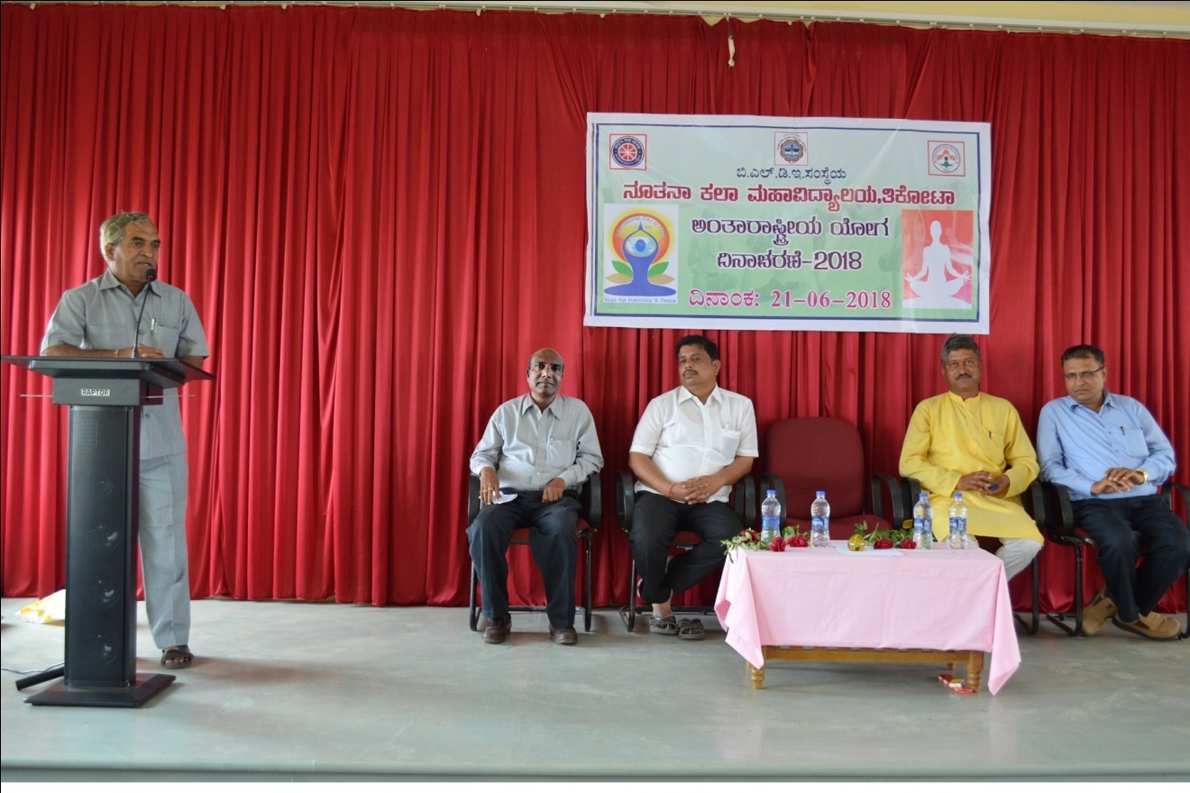
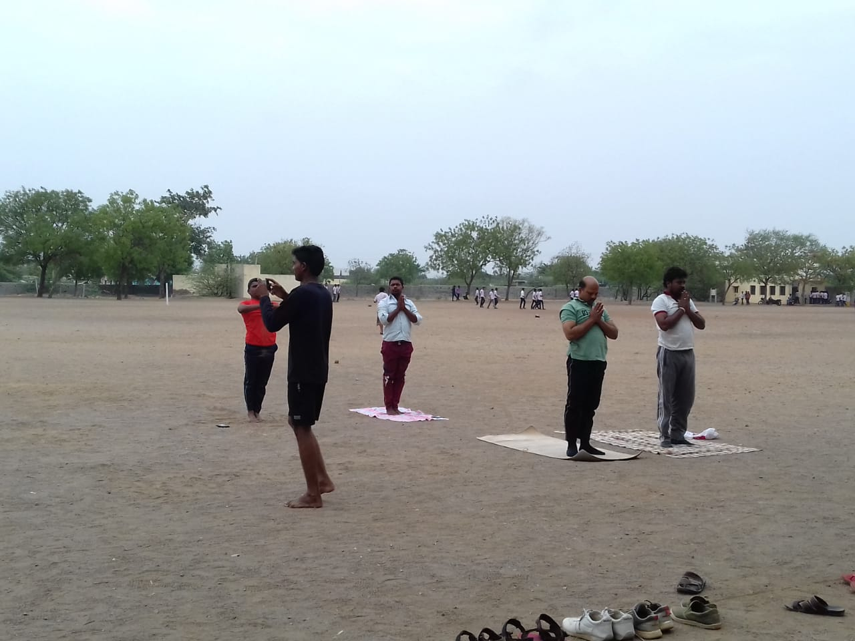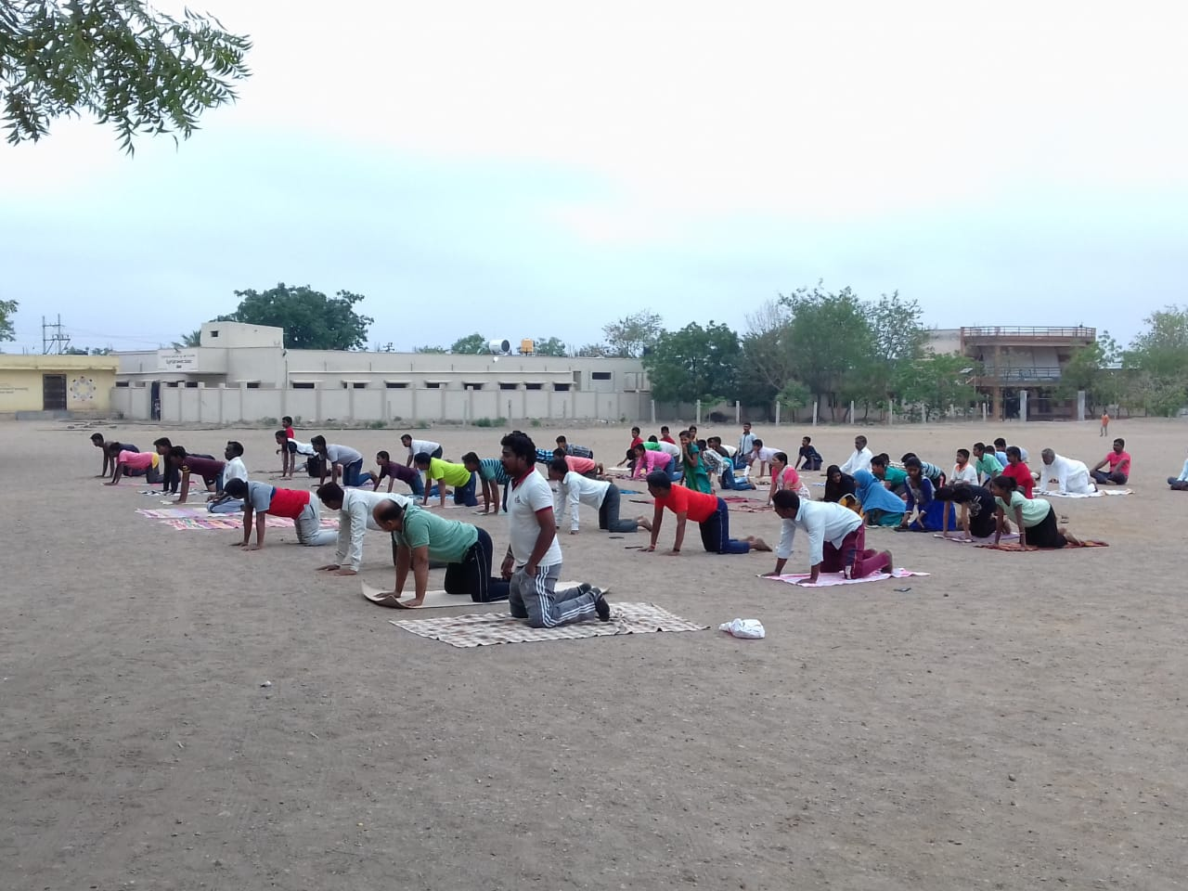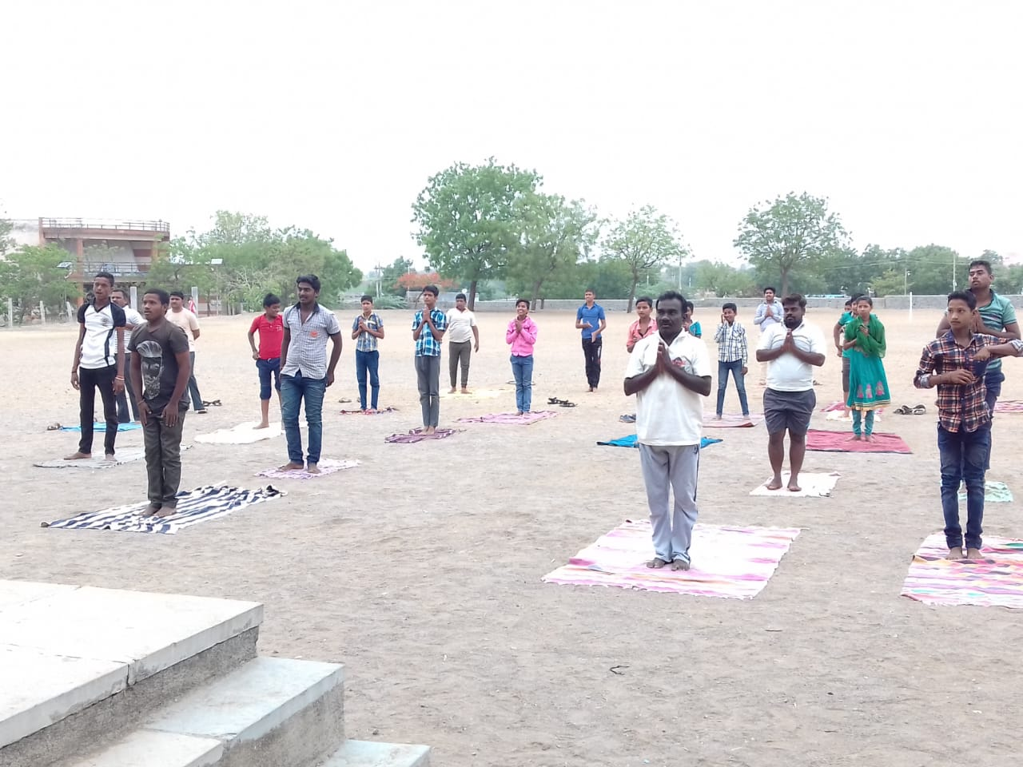

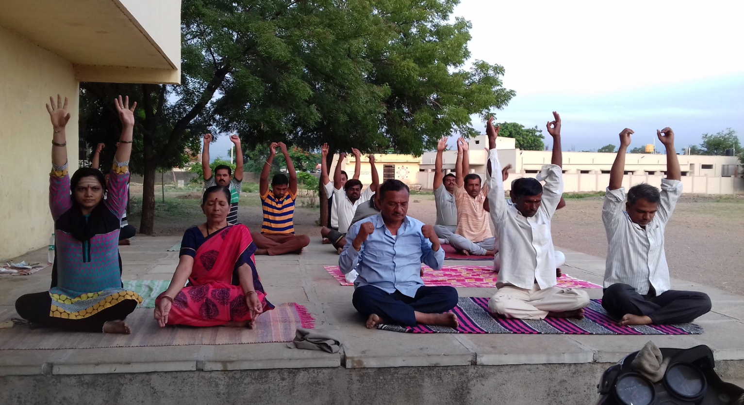
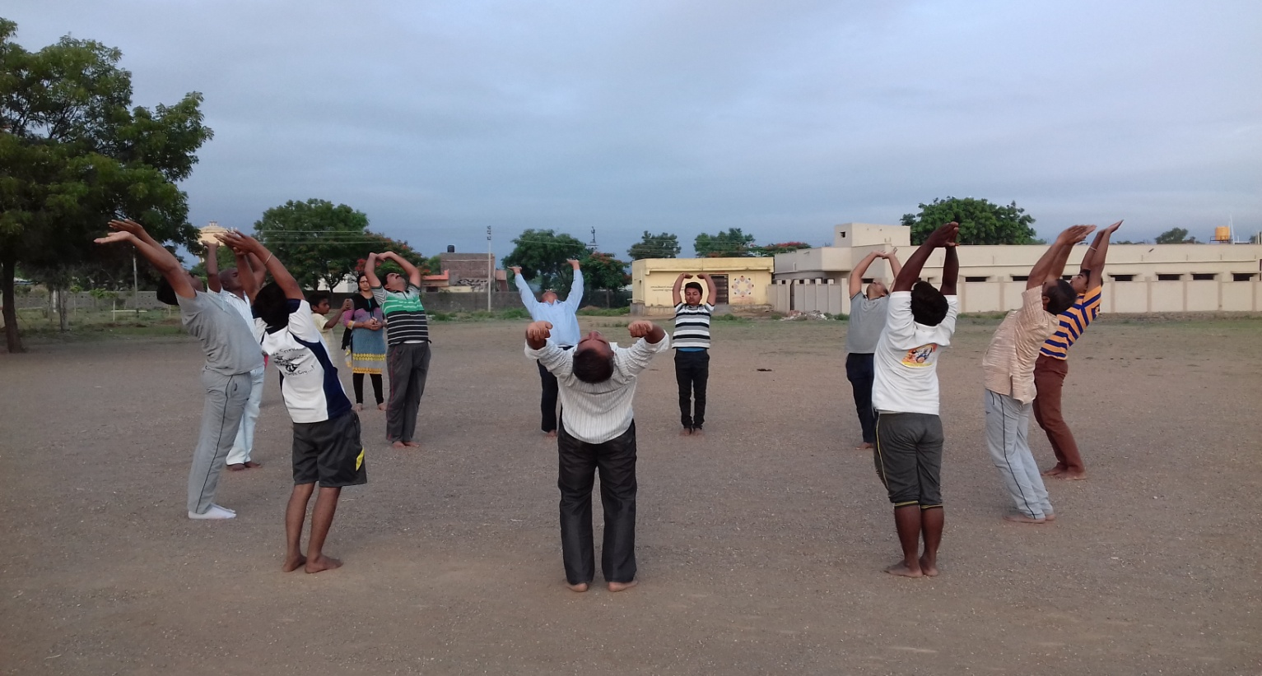

Tree Plantation
On 9-7-2016, under the guidance of Dr.M.B.Bhiradi, Principal, New Arts College, Tikota, hundreds of saplings were planted in the campus of the college.
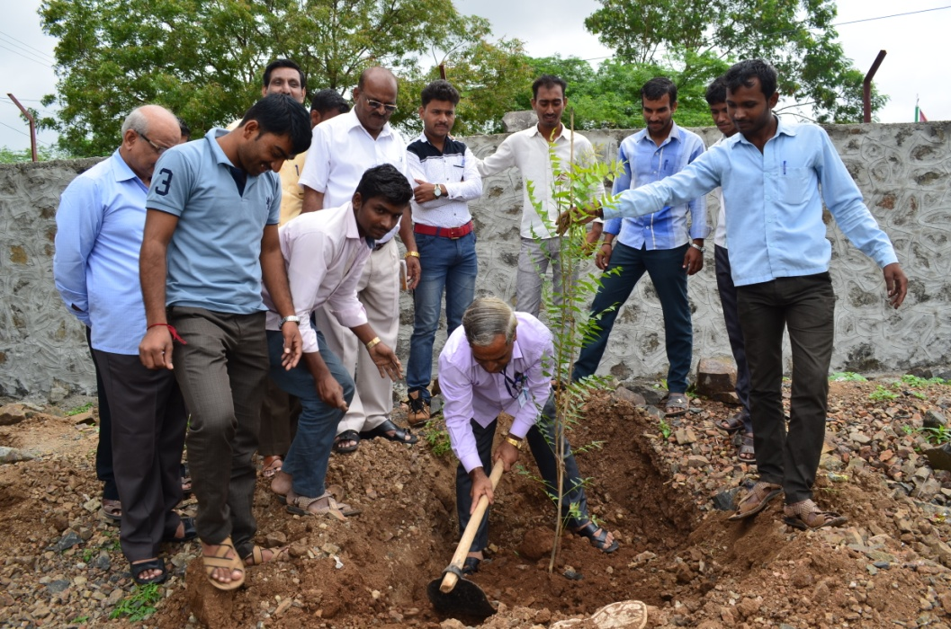

Swachh Bharat Abhiyan
The Scouts and Rovers students conducted Swachh Bharat Abhiyan on 02-01-2017 on the occasion of Swami Vivekananda's 154th birth anniversary celebration.

AIDS Awareness Rally
The Scouts and Rovers students participated in the AIDS Parade on 30-8-2017 at 10:00 a.m. in the adopted village Rampur. The students were called out the slogans and spread the awareness about AIDS in the village.

World Tribal Day
World Tribal Day was observed in the college on 13/08/2019 by the Cultural Committee, Kannada Jaanapada Parishat, Tikota and NSS Units. Tribal artists from surrounding villages were invited and honored with certificates and honorarium.
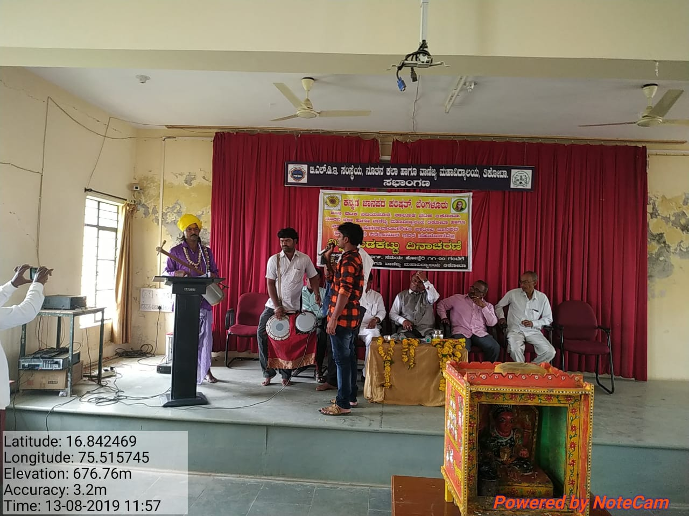
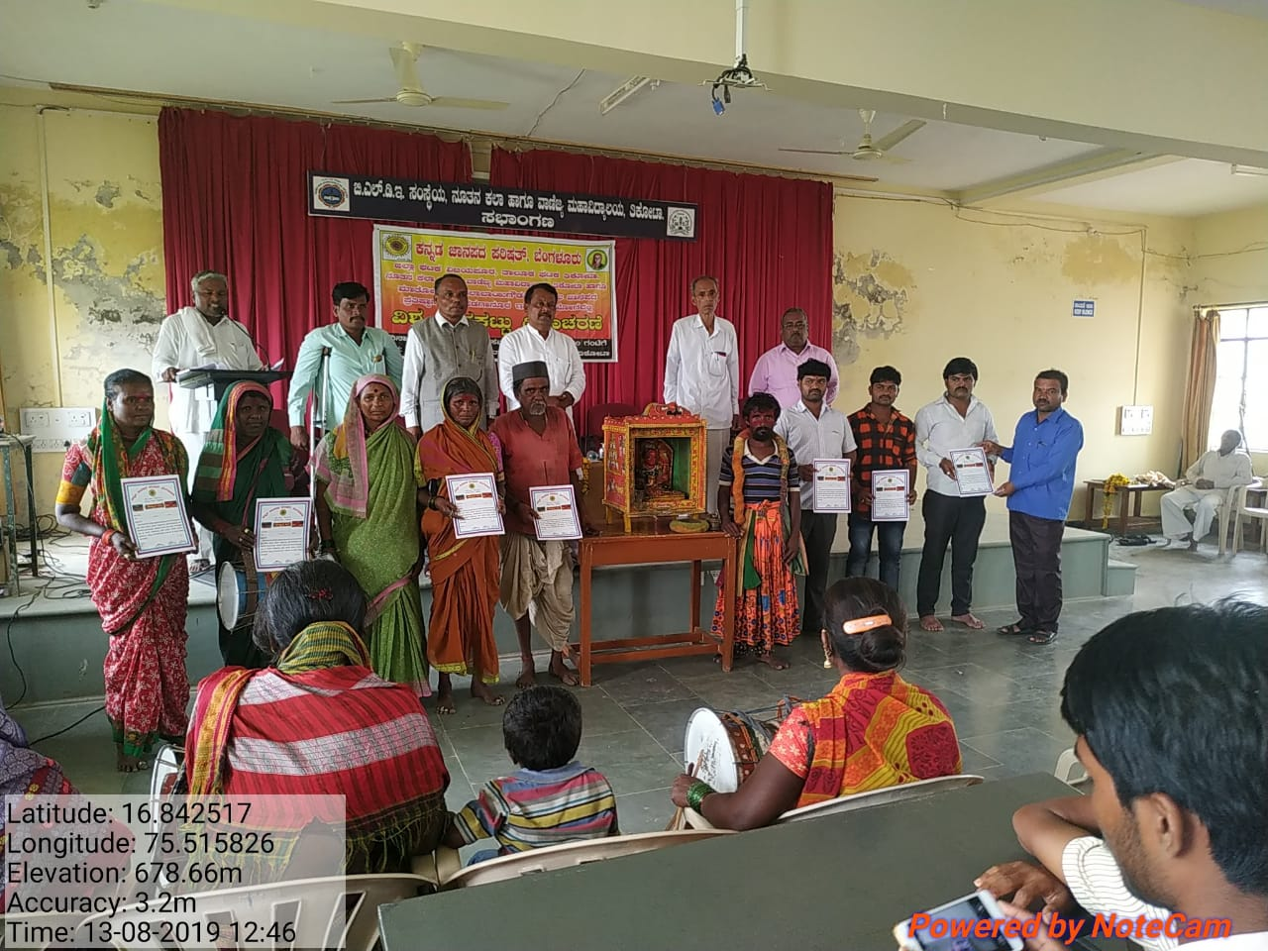
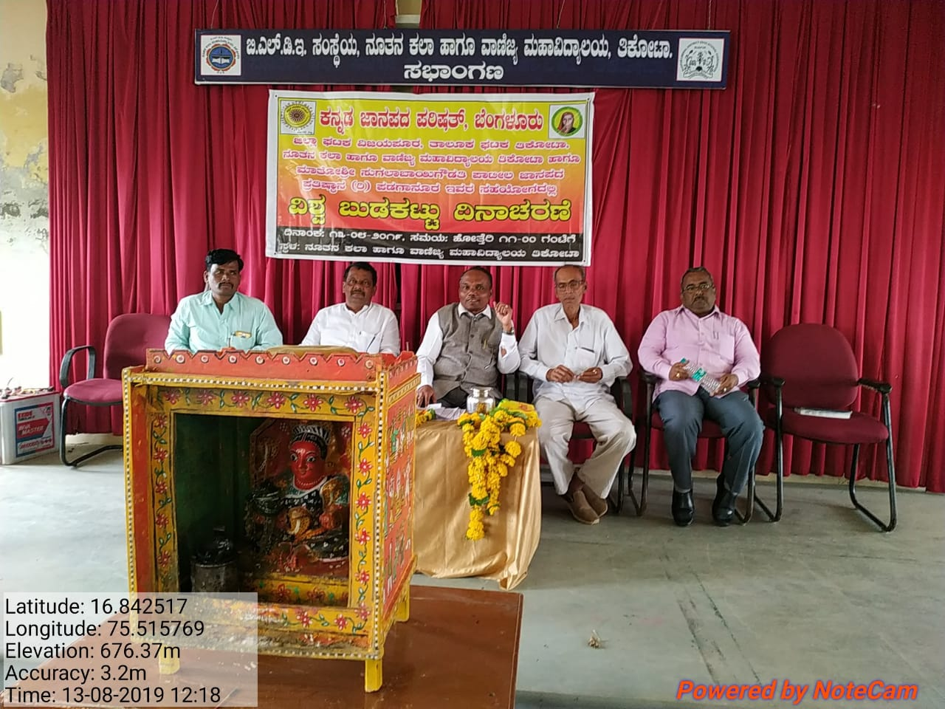

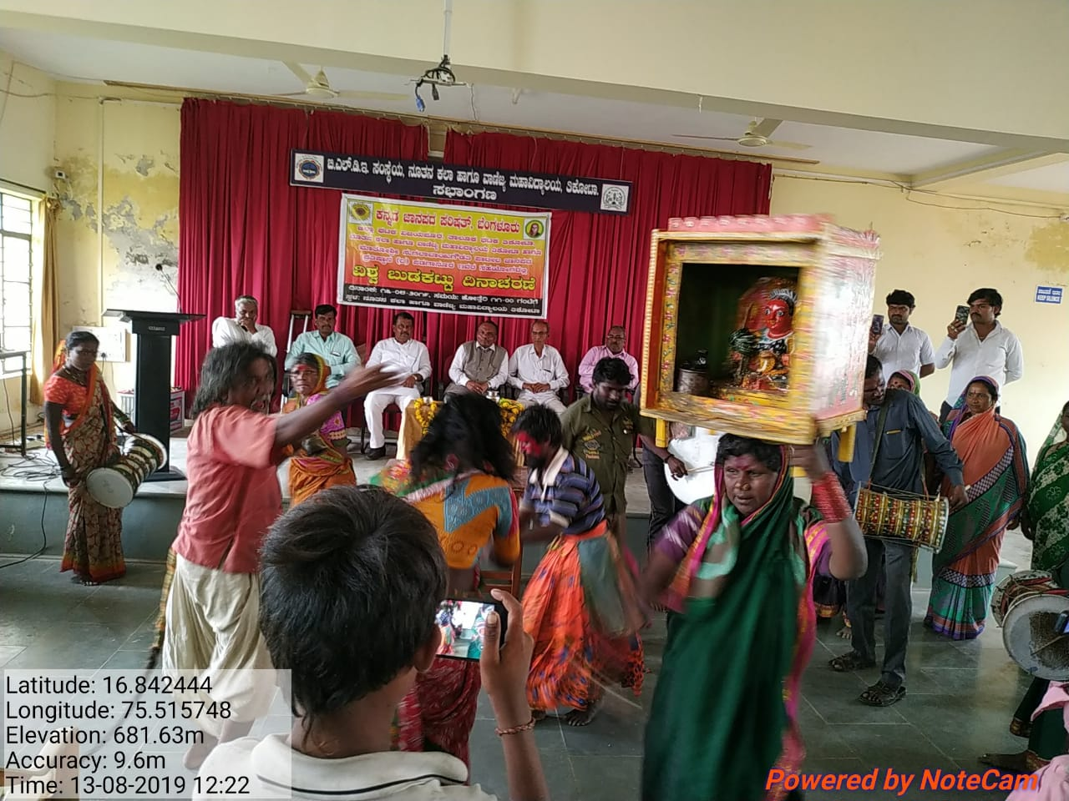

N.S.S Unit I & II Special Camp
The N.S.S Special Camp has been organized in an adopted village Rampur from 28-12-2017 to 03-01-2018. Smt. Pratibha Patil, Zilla Panchayat Member, Tikota, inaugurated the N.S.S Unit I & II Special Camp by watering the sapling. “Youth for Science & Scientific Attitude” was the motto of the Camp. Shri. D. Dayanand, District Coordinator, Nehru Youth Centre, Vijayapur, was the Chief Guest of the Camp. Prof. H.M.Sajjade, District Nodal Officer, N.S.S, Vijayapur, Shri.Mallikarjun Vanti, H.D.M.C Chairman, Rampur were also invited as the Guests of the Camp. Dr.M.B.Bhiradi, Principal, New Arts College Tikota was the President of the Camp.
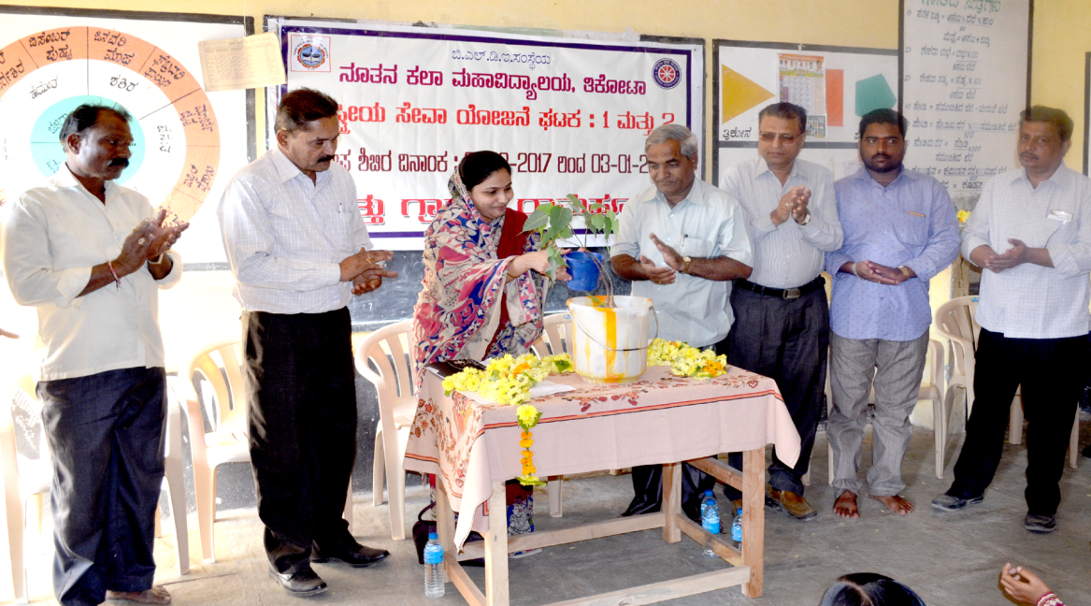
Smt. Pratibha Patil, Zilla Panchayat Member, Tikota, inaugurated the N.S.S Unit I & II Special Camp by watering the sapling
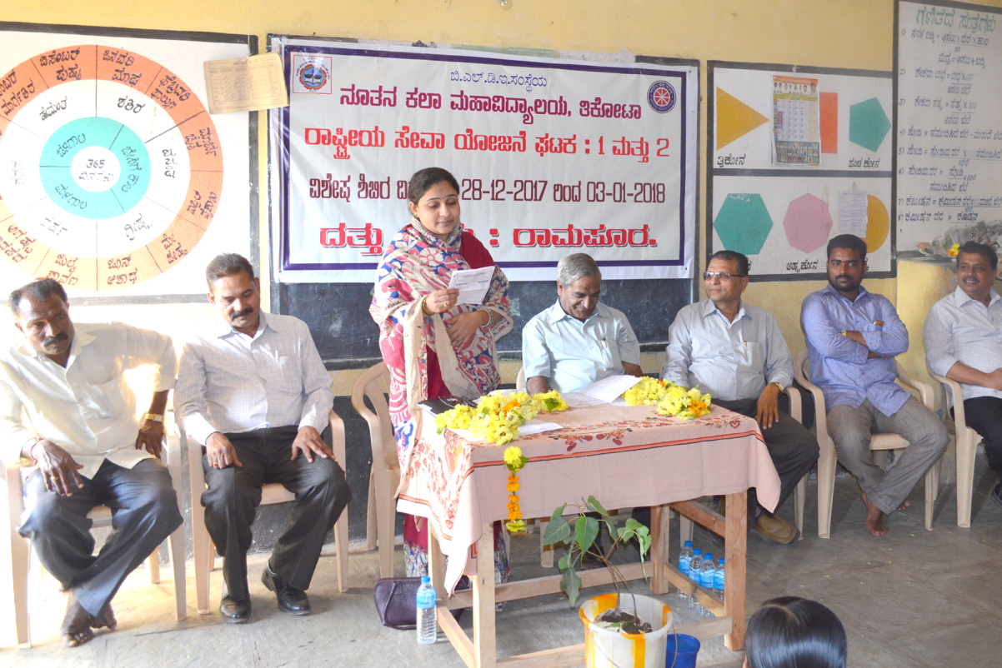
Smt. Pratibha Patil, Zilla Panchayat Member, Tikota, presenting the Speech during her Inaugural address.

The NSS Special camp activity was commenced on December 28th, 2017 at 6:00 a.m. by hosting the flag. After the breakfast, 12 teams were formed and were sent for the survey of the toilet rooms in the village. Later, Prof. M.D.Biradar, Assistant Professor of Political Science, New Arts College, Tikota gave Special Lecture. Nazeer Ahmad Jamadar, the Gram Panchayat Member, Rampur was the Giest of the programme. Prof.S.A.Bhajantri, Prof.S.P.Uppar, Prof.R.S.Chavan were also present. Dr.S.P.Madrekar was the President of the programme.
As a ritual the activity of NSS special camp commenced on December 30th, 2017 by hosting the flag. After the breakfast, the cleanliness programme was conducted in the adopted village Rampur. The special lecture was the held on the 'Awareness on the Prevention of Female Foeticide' by the Resource Person Dr.B.Nandini,the Physician, Primary Health Centre, Tikota. Prof. V.R.Patil, Prof.R.Ullagaddi, Prof.the Grama Panchayat Member Prof. R.B.Awati were invited as the Guests of the programme. Dr.S.S.Biradar, H.O.D, Sociology Department of New Arts College, Tikota, was the President of the programme.
As a ritual the activity of NSS special camp commenced on December 31st, 2017 by hosting the flag. After the breakfast, The Cleanliness Programme was conducted in the major spots of the village such as Shri Sadashiv Math, Anganawadi, and Primary School Campus, In relaxation period, the cultural programmes were conducted. The Principal of Kittur Rani Channamma School Shri Satish Sajjan has delivered the topic on "Historical Monuments and the Protection". His Holiness Vidyananda Swamiji was the Guest of the programme. Prof. R.B.Sirasangi was the President of the programme.
As a ritual the activity of NSS special camp commenced on January 01, 2018 by hosting the flag. After the breakfast, the Cleanliness programme was conducted in Primary Health Centre, Tikota. In relaxation period, the cultural programmes were conducted. Prof.R.B.Sirasangi delivered special lecture on “Water Enrichment and Usage”. Prof. Konasirsagi was the Chief Guest of the programme. In his Presidential remarks, Dr.M.B.Bhiradi explained briefly about the appropriate usage and preservance of water.
As a ritual the activity of NSS special camp commenced on January 01, 2018 by hosting the flag. After the breakfast, Aids awareness parade was conducted in the major places of the adopted village, Rampur. The N.S.S volunteers actively participated in the parade by calling out the motto for the prevention of AIDS. Dr.J.M.Bilagi, District Aids Prevention Officer, Vijayapur gave special lecture on the awareness of AIDS. Dr.M.S.Viranghimath was the President of the programme.
The Valedectory programme of N.S.S Special camp was conducted on January, 3rd, 2018 in association with Nehru Youth centre. Shri.R.T.Uttarakar, Director, RUDSHET, Vijayapur was the Chief Guest of the Programme. Shri.A.V.Honawad, Head Master of Government Primary School, Rampur, Prof.A.G.Tapashetti, H.O.D, Statistics Department, New A

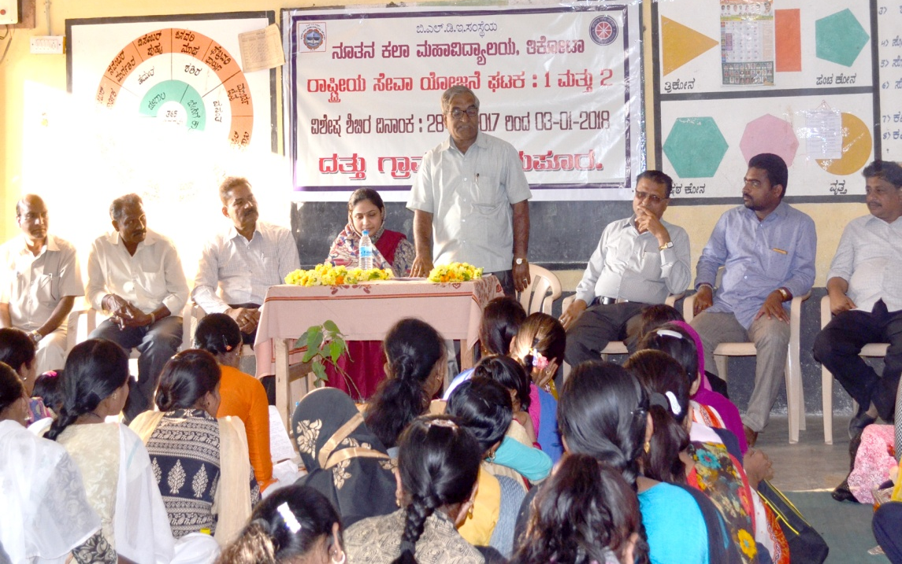

Swami Vivekananda’s 155th Birth Anniversary &
National Youth Day
On the special occasion of youth icon Swami Vivkanada’s 155th Birth Anniversary celebration and National Youth Day, various programmes were held in the premise of the college from 12-01-2018 to 19-01-2018 which aimed to empower Youth and develop National Integrity among youngsters,
The programme commenced with the Parade in Tikota held by the Faculty and Students of the College. Smt. Pratibha Patil, Zilla Panchayat Member, Tikota, inaugurated the Parade by lighting the lamp. The Parade participated in the inaugural programme of the National Youth Day by various governing & Civic bodies such as Ministry of Youth Affairs & Sports of Indian Government, State Government, District Administration, Zilla Panchayat, Nehru Youth Centre, Youth Empowerment and Sports Department, District N.S.S Units, Vijayapur.
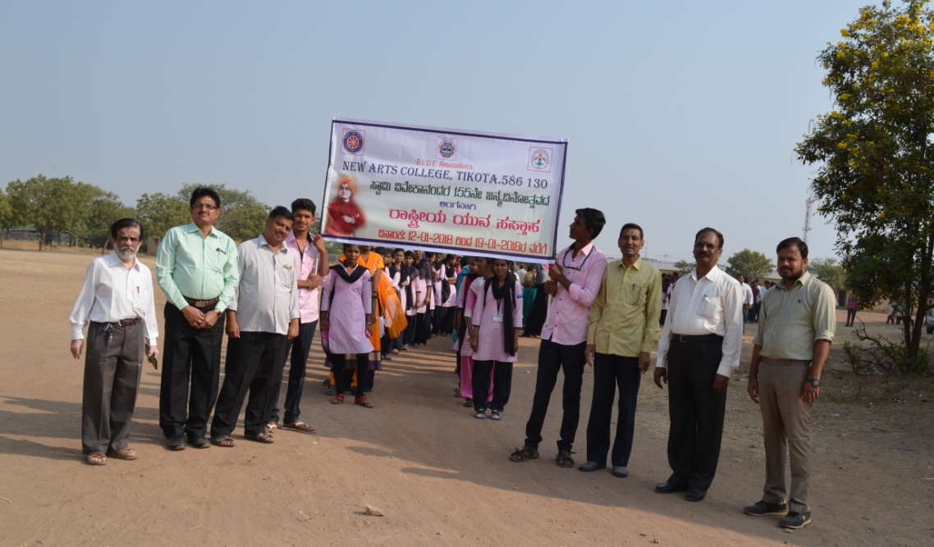
Faculty and Students during the Parade

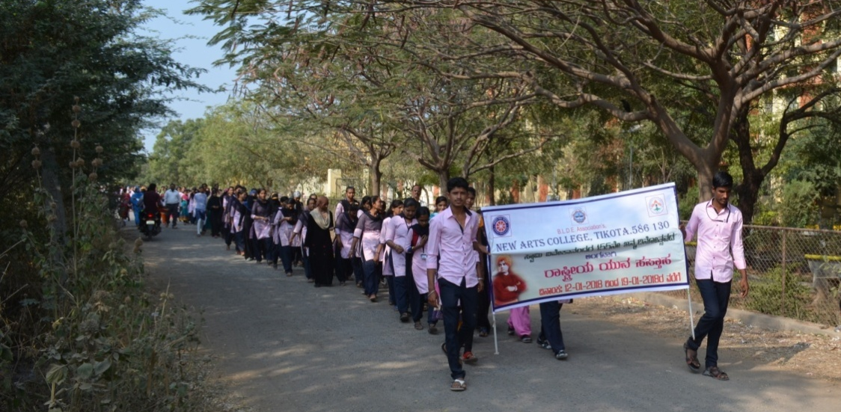
Faculty and Students during the Parade

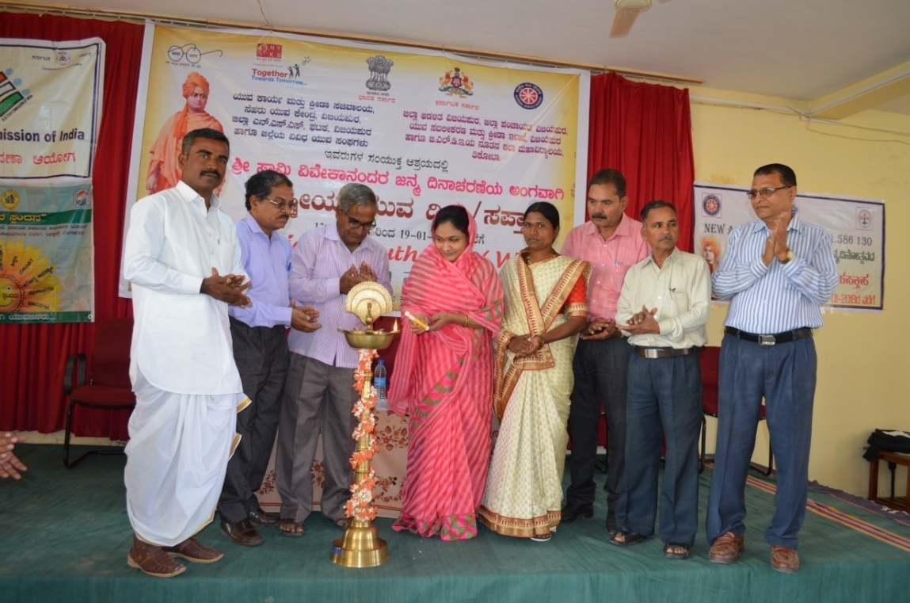
Smt. Pratibha Patil inaugurating the National Youth Day programme

Blood Donation Camp

Blood Donation camp has been organized in the college in collaboration of N.S.S Units and Scouts & Guides. B.L.D.E.Association’s Medical College Officials on 16-2-2018. Few students involved in this noble cause by voluntarily donating blood.

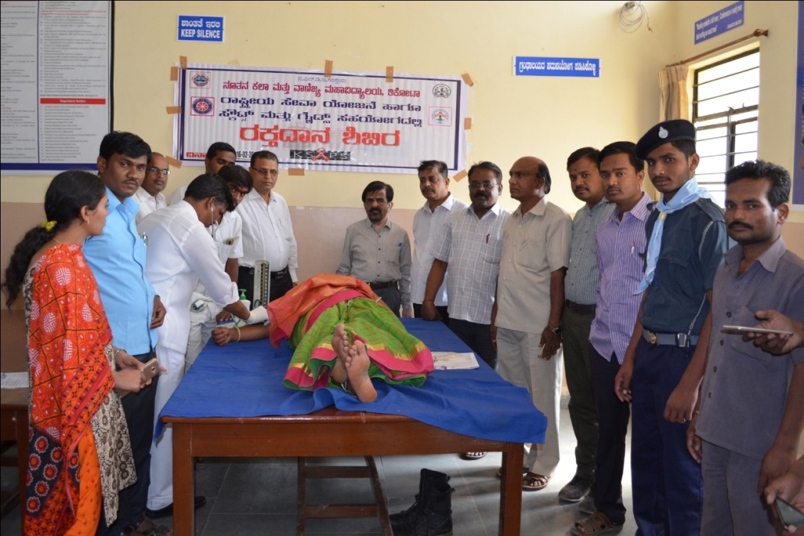

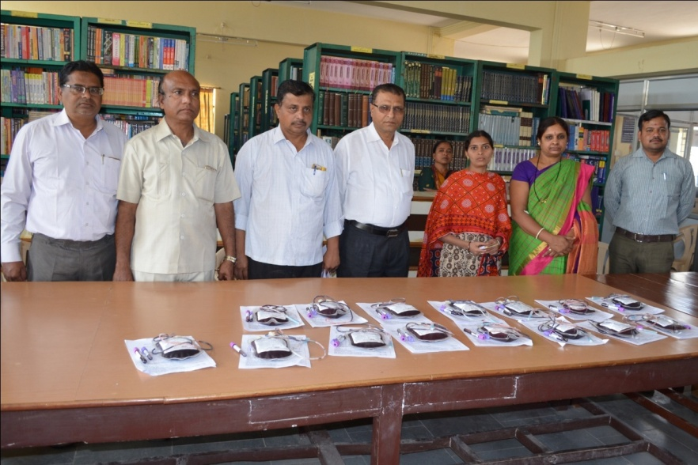

Social Service at Shravana Belagol
11 members of the Scouts and Guides unit of the college rendered social service for 5 days at Maha Mastakaabhisheka of Gomatesh Statue at Sharavana Belagol held from 21-02-2018 to 24-02-2018. The team was applauded by the District Commissioner of Hassan, Karnataka for their selfless service.
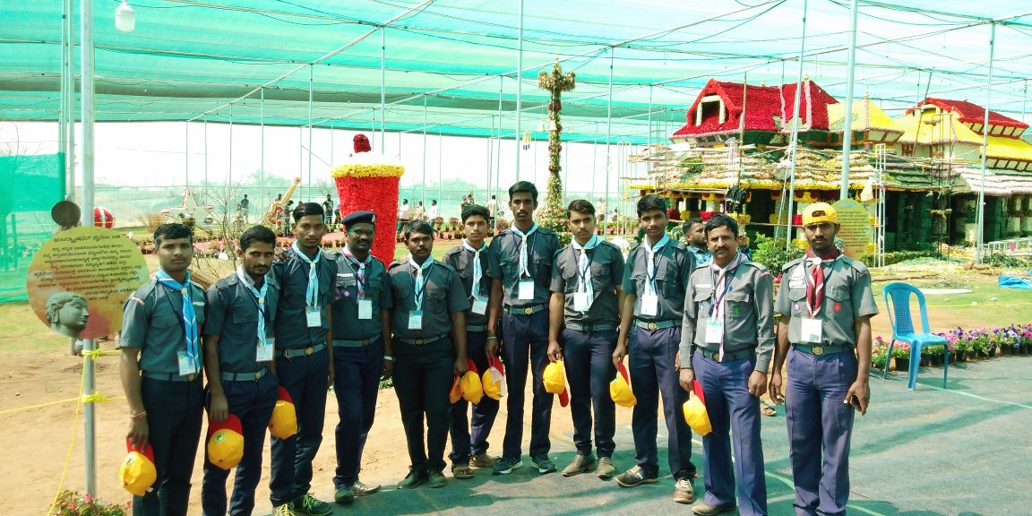
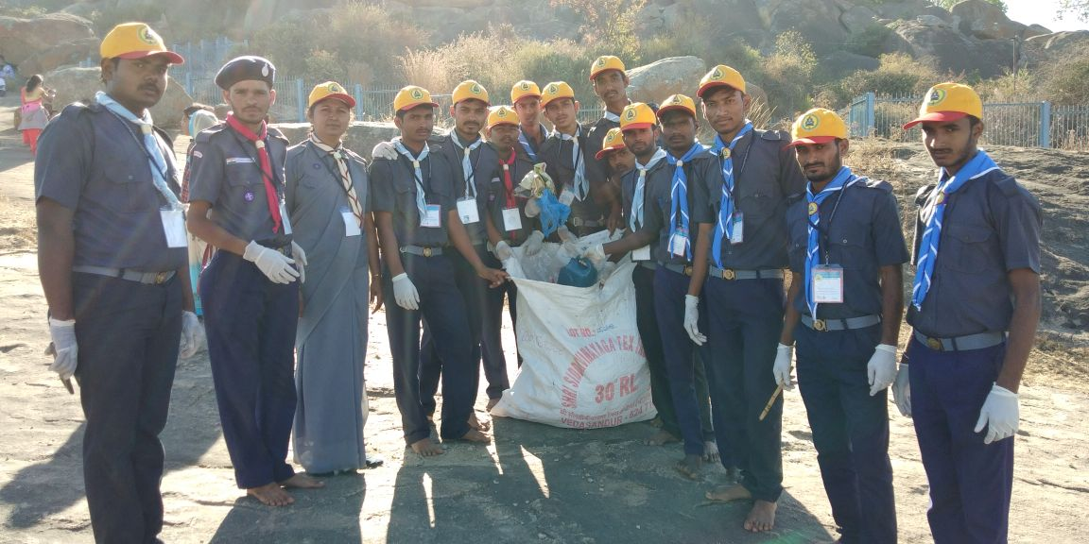

Swachh Bharat Abhiyan
The Swachh Bharat Abhiyan was conducted in the college from 01-08-2018 to 05-08-2018. Likewise, the N.S.S volunteers took the charge of cleaning the college campus, all classrooms, washrooms, playground, and Ashraya colony. Faculty and students spread the awareness among the residents on keeping their surrounding and environment clean.
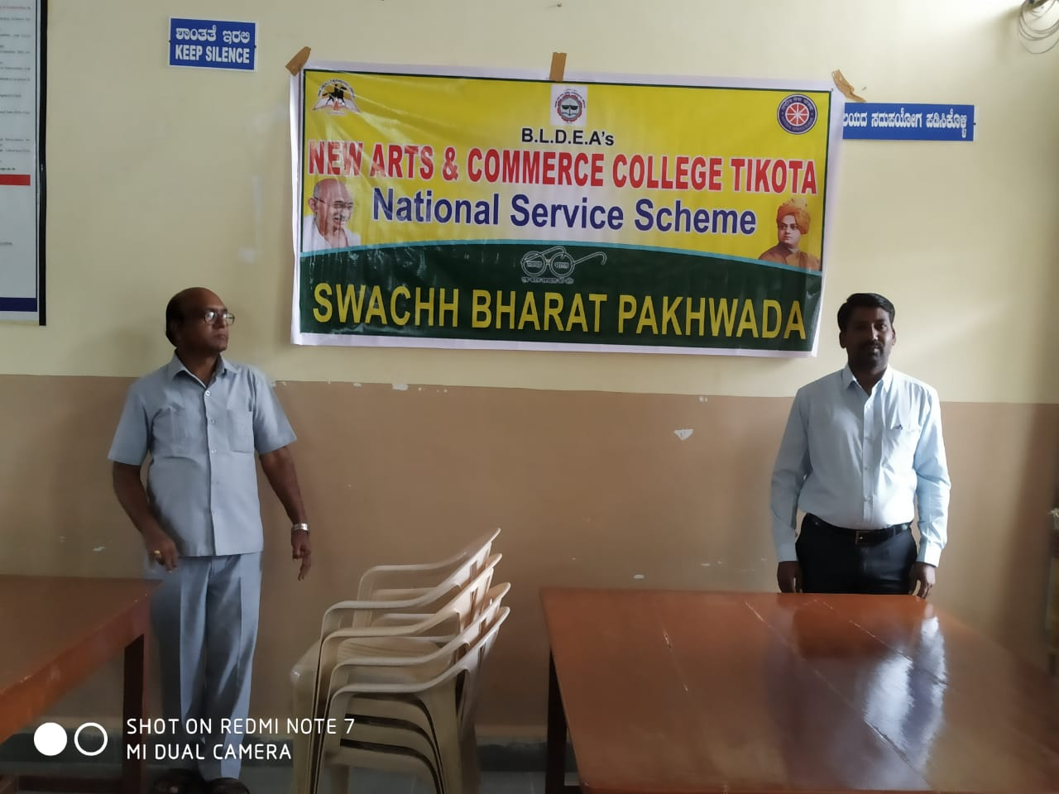
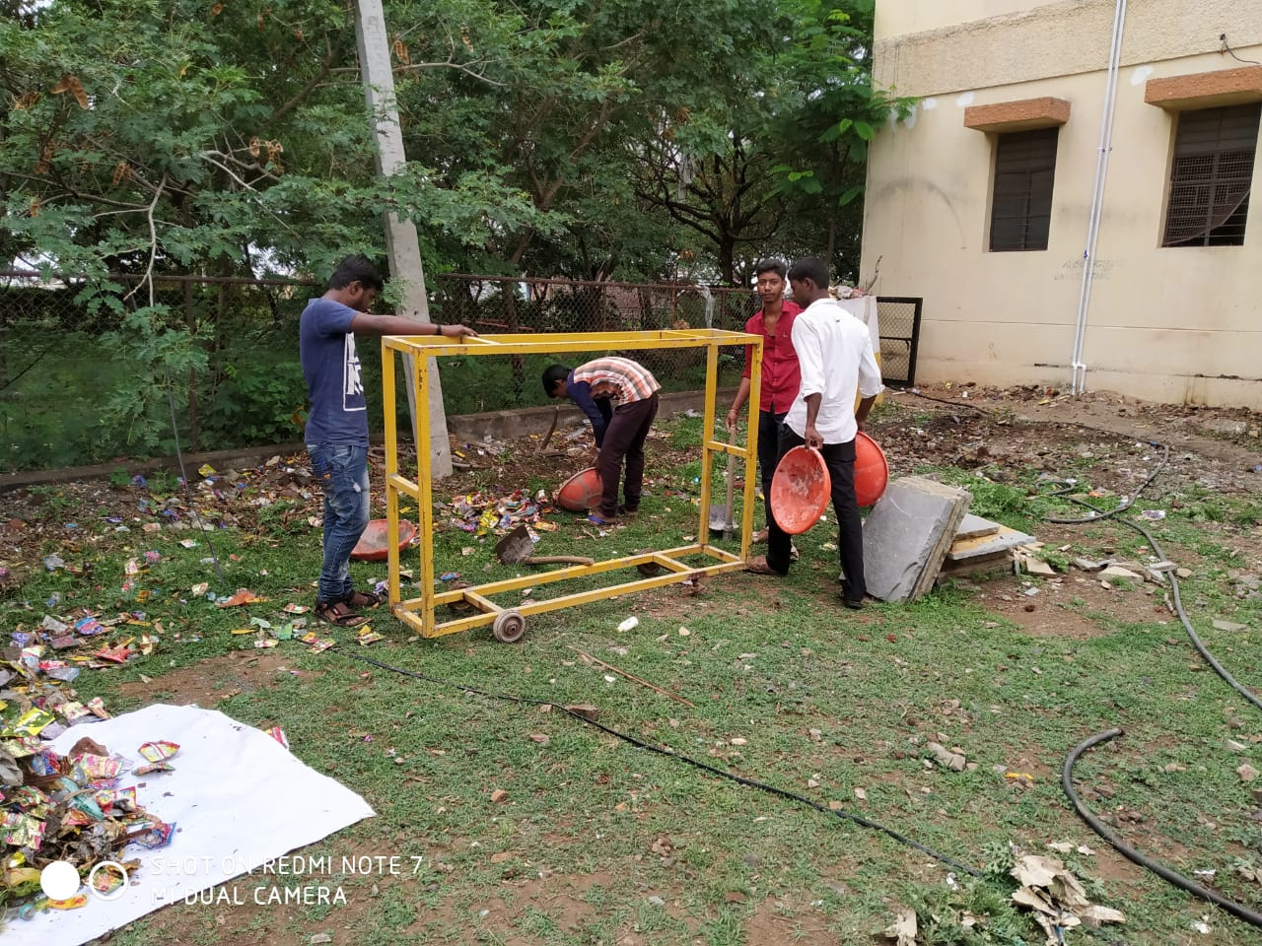

Awareness Rally Against Corruption
The program of ‘Awareness on Corruption’ was held in the college on 29-10-2018. Shri.K.S.Rayamane, CPI of Police Department was the Chief Guest of the program and he aimed to raise awareness of the risks of corruption and establish a sustainable system of national integrity. He spoke about the role of public in the eradication of corruption and urged the public to take pledge of not involving in the corruption activities. The Parade was also held in the major places of the city with the motto of spreading awareness on corruption and bribery. Dr.M.B.Bhiradi, Principal of New Arts College presided over the program. All the teaching, non-teaching staff and Students were present during the occasion.

Campaign on AIDS Awareness
The Faculty and Students of B.L.D.E.A's New Arts and Commerce College, Tikota participated in the 'Campaign on AIDS Awareness' on 11-1-2019 in Babanagar. In the campaign, students called out the various slogans on AIDS and spread the awareness about the disease and its prevention. Smt.Annpurna Patthar, Counselor of Al-Ameen Medical College, Vijayapur gave a lecture on 'HIV AIDS' and enlarged the information about the same. Shri Parmanand Kanmuchnal, the Gram Panchayat Member of Baba Nagar, Prof.S B Desai, Head of English Department, Dr.M.B.Bhiradi, Principal of New Arts College presided over the program. All the teaching, non-teaching staff and Students were present during the occasion.

Blood Donation camp
Blood Donation camp has been organized in the college on 13-03-2019 in collaboration of N.S.S Units and Scouts & Guides. B.L.D.E.Association’s Medical College Officials monitored the camp. In total 19 students involved in this noble cause by voluntarily donating blood.

N.S.S SPECIAL CAMP
N.S.S Special Camp was conducted in the adopted village Babanagar from 10-02-2020 to 16-02-2020. The N.S.S Special Camp has been organized in an adopted village Babanagar, from 10-02-2020 to 16-02-2020. Shri.Anil Kamble, Gram Panchayat President, Babanagar, inaugurated the N.S.S Unit I & II Special Camp by watering the sapling. “Youth for Science & Scientific Attitude” was the motto of the Camp. Prof. H.M.Sajjade, District Nodal Officer, N.S.S, Vijayapur, was the Chief Guest of the Camp. Smt.S.D.Halli, Headmistress of Babanagar Highschool, Shri. S.B.Dengannavar, Head of Kannada Department, B.L.D.E.A’s S.B.Arts & K.C.P Science College, Vijayapur, Shri.A.G.Tapashetti, Head of Statistics

As a ritual the activity of NSS special camp commenced on January 01, 2018 by hosting the flag. After the breakfast, the Cleanliness programme was conducted in the village. Later, Special Lecture programme was conducted on 11-02-2020 at 4pm on the topic ”Awareness on Environment” by Shri.S.T.Mulla, Headmaster of Government High School Babanagar. Shri.Honappa Kannal, S.D.M.C President, Babanagar and Shri. Paramanand Kanmuchnal,Grampanchayat member, Babanagar were the Guests of the programme. Prof.P.B.Patil, Head of Education Department was the President of the programme.
Shri.Ramesh Khyadi-Headmaster B.A.K High School, Bijjaragi- delivered special lecture on “Water Enrichment”. Shri.Sureshgouda Biradar, President, A.P.M.C, Vijayapur and Shri. Revanasidd Danagond, Gram Panchayat member, Babanagar, were the guests of the program. Dr.S.L.Rathod, Head of Hindi Department was also present. Dr.S.N.Waghmare, Geography Department was the President of the programme.
Special Lecture was conducted on 13-02-2020 on the topic “Health Awareness for Men and Women”. The Chief Guest was Shri.Iranna Dharwadkar, District AIDS & T.B Prevention Officer, and he gave knowledge to the public on the various health issues such as HIV AIDS, T.B. He discussed the importance of blood donation and he even disseminated the ill-effects of Tobacco consumption. Dr.M.B.Singe was the President of the programme. Street Play on AIDS was performed during the occasion by Kumar.Sanjiv and Shirdhar. Prof. H.M.Sajjade, District Nodal Officer, N.S.S, Vijayapur, Dr.S.P.Madrekar, Principal, B.L.D.E.A’s New Arts and Commerce College Tikota were present during the occasion.

Free Vaccination Against COVID-19
For Students, Staff And Public
Date: 30/06/2021 and 01/07/2021
Brief descriptions/Details of Event:
This event was jointly organized by IQAC, NSS Units, YRC, Scouts and Guides of the college in association with Taluka Administration and Primary Health Center, Tikota. Two staff members, 457 students and 65 persons from local community were vaccinated.

Photos of the Event

