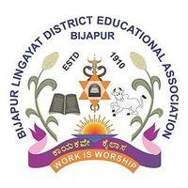

BLDE Association’s
New Arts College, Tikota
Dist. Vijayapura – Karnataka State
(Accredited with ‘B’ Grade by NAAC)
Affiliated to Rani Channamma University, Belagavi
Email: nac_tikota07@yahoo.co.in Website: www.bldeanacct.ac.in
Phone No: 08352-231932 Mobile No: 9448972457
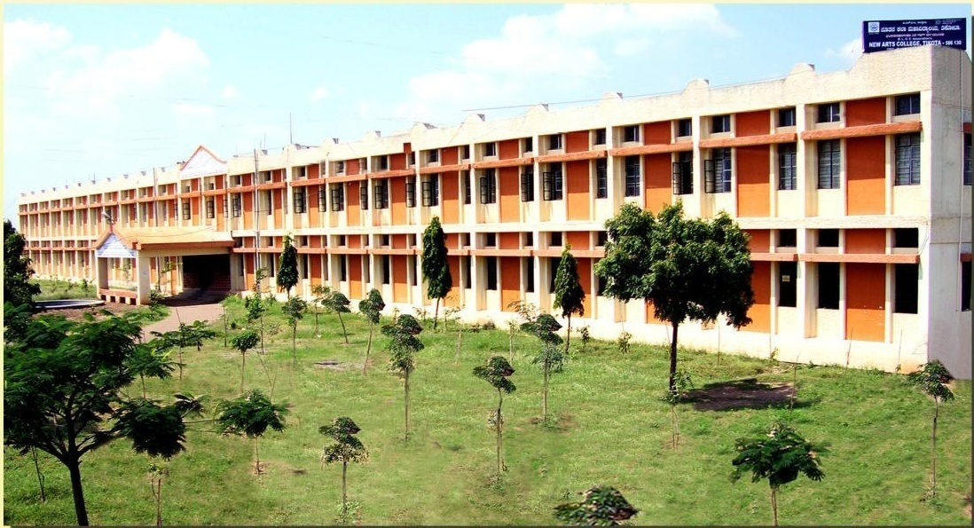

PROSPECTUS: 2016-17

B.L.D.E. Association, Vijayapur
Key Builders of Institution

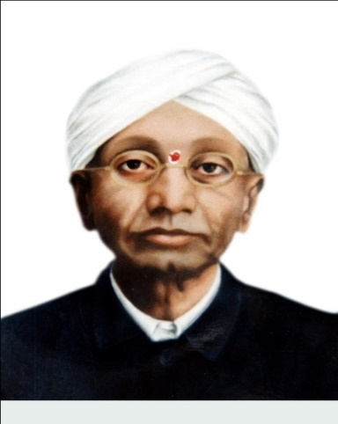

“Vachana Pitamaha”
Dr. P.G.Halakatti
Distinguished Men of Letters
Founded B.L.D.E Association

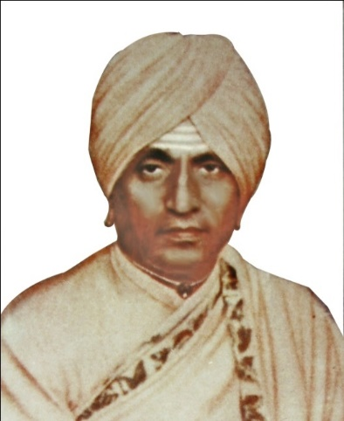

His Holiness
Shri Sangana Basava Swamiji,
Fostered his disciples with visionary aim of providing education for rural youth.

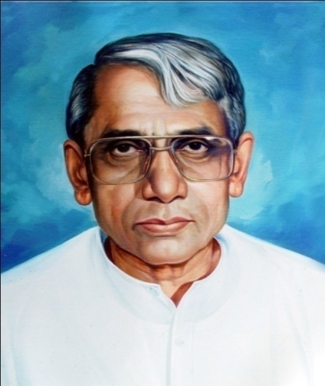
74Great Visionary
Shri B.M.Patil B.Sc . (Hons ),LLB
Nurtured and Elevated Association to its present academic, with qualitative and quantitative heights.

VISION
“Empowering the rural youth for facing the challenges of the world”

MISSION
“Creating facilities to inculcate global skills and value systems among the rural Students by providing computer literacy, communication skills and holistic approach with excellence leading towards national development”

Objectives
• To facilitate the education for empowering the rural youth with global competency.
• Imparting a value system among students.
• To create awareness on ecology, environment and heritage
• Promoting the use of ICT

BLDE Association: An Epitome of Excellence :

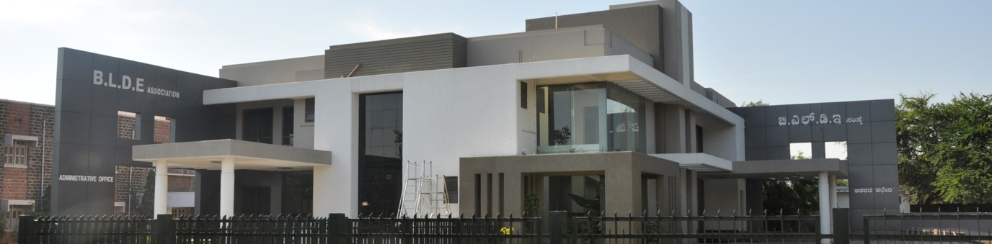

ABOUT THE BLDE ASSOCIATION:

The Vijayapur District was socio – economically and educationally backward area. Then, it had a silver lining and a ray of hope when the great eminent personalities of this region established Vijayapur Liberal District Education Association in 1910 with a visionary zeal and positive attitude to impart education. It is our proud privilege to give a brief history of our Association.
The BLDE Association, Vijayapur in Karnataka State, is an esteemed and prominent educational association fostered by distinguished philanthropists and men of letters like Vachana Pitamaha Dr. P.G.Halakatti, His Holiness Shri Sanganabasava Shivayogi of Banthanal and their disciples with the visionary aim of providing education particularly for the rural youth in this socio-economically backward region. Further, its patron, Late Shri B.M.Patil, the then Minister in the Govt. of Karnataka nurtured and elevated it to its present academic, qualitative and quantitative heights.

Within a span of a century, the Association has witnessed an amazing and spectacular growth in all its spheres of academic pursuits by the devotion and dedication of charismatic leader Shri M.B. Patil, the President and Chairman of BLDE Association and the Minister for Water Resources, Govt. of Karnataka. The association has reached its pinnacle of heights by running more than 80 institutions in all disciplines including Medical, Engineering, Law, Management, Arts, Science, Commerce, Pharmacy, Ayurvedic, Polytechnic and CBSC schools. Under the guidance of a renowned academician Shri. G.K.Patil _{Ex} MLC, the General Secretary and Treasurer of BLDE Association, all the institutions have proved a great success in the field of Education.

The BLDE Association has observed its Centenary Year Celebration in 2010 by functioning as a Parental Umbrella to all the institutions in which around 6000 Teaching and Non-teaching staff are serving. The association caters education to around 30000 students in all disciplines. It has laurels of obtaining Deemed University status for Medical College in 2008.

ABOUT THE COLLEGE:

On the eve of Golden Jubilee Celebration, the New Arts College, Tikota came into existence from 16th June 1969 at Vijayapur. As the two Arts colleges were in the same campus at Vijayapur, the association decided to shift the college to Tikota to provide education to the rural backward students. The college was started in Tikota to serve the downtrodden, disadvantaged, rural educationally backward people of Tikota and its surrounding villages, which is 20 kms away from the historical city, Vijayapur.
The New Arts College, Tikota is one of the renowned and eminent institutions of BLDE Association among the rural institutions of the district. Prof. S.S.Kabbin was the first principal of the college. The college had the good fortune of having, devoted educationists as the principals. The college has been able to maintain its students enrollment at about 500-600 in spite of many newly introduce colleges and working in the surrounding area.The college faculty consist of dedicated and research oriented professors with 7 Ph.D’s and 2 M.Phills with 1NET passed and non teaching members. The distinctive institution is that about 90% of students belonging to economically dis-advantaged agricultural family of tikota taluka and surrounding villages. At present, Dr M.B.Bhiradi, an eminent hard working personality is serving as the Principal of the college. He is a very good academician and administrator.
During a span of few years, the college has flowered into a dedicated educational institution fulfilling the dreams, desires, and aspirations of the people of the socio- economically and educationally backward rural area.
The college has not rested upon its past glory. It is consistently trying its best to provide quality education to the rural youth to fulfill their dreams and aspirations.

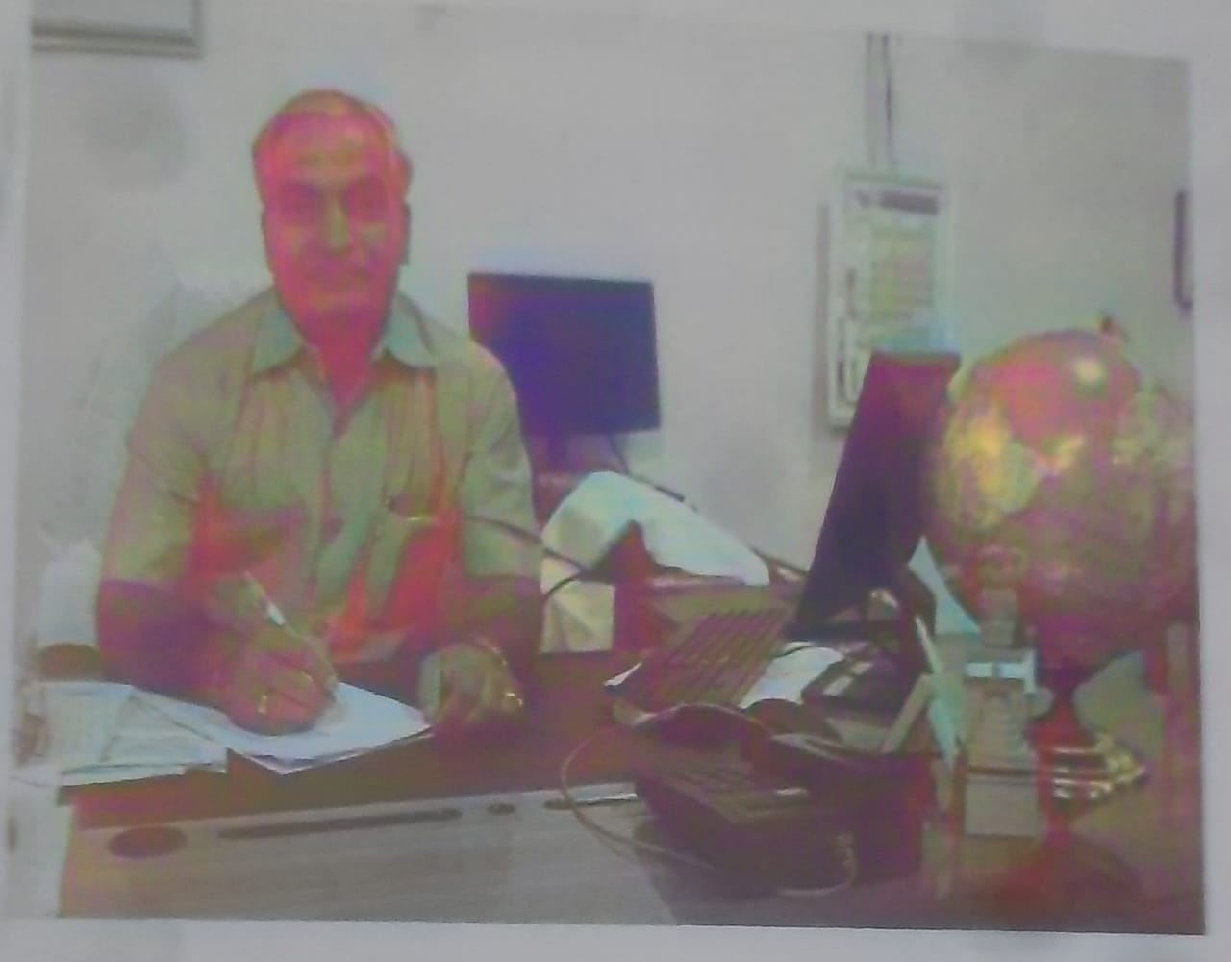
From the Principal’s Desk

Dear Students,
Education is the Chief Defense of the Nation. It is a life building, character building, assimilating fine ideas and ethics incorporating them in one’s life. This is exactly what our institute aims at. The college has successfully completed 48 years of its establishment. It has been a journey of challenges, commitments and fulfillment of the dreams of our founding fathers and predecessors. We are really fortunate enough to have a galaxy of devoted and dedicated teachers and a supportive non-teaching staff. All of them have been striving hard for the academic standards and the better quality of academic environment in the college campus. The college has got its own magnificent building for All the departments and especially for the library now it is a self sufficient in every respect.
We sincerely Express our Thanks to all our faculty staff and students for the active participation in all the activities of the college. We acknowledge the deep sense of appreciation and their cooperation extended by the members in bringing out the prospects we have pleasure to present to the college prospectus for the academic year 2016-17.


Bachelor of Arts (B.A)
B.A Program offers Part I, Part II, and Part III Subjects. Part I & Part III are Compulsory Subjects whereas Part II is of Optionable nature where Students can choose Subject Combinations.
Duration: 03 Years
Eligibility: PUC/10+2/Equivalent Examination
Part I
- Languages:
- Basic Subjects: English is compulsory from BA I Sem. to BA IV Sem.
- Modern Indian Language (MIL): Kannada,
Part II
Three subjects of equal importance:
(Choose only three subjects from four Groups selecting one from each group)
Group A: Applied Statistics/Kannada/English
Group B: History and Archaeology/Political Science/Sanskrit/Home Science
Group C: Hindi/Geography/Sociology
Group D: Economics/Education/Agricultural marketing
Part III
Core Subjects:
- First Semester : Indian Constitution
- Second Semester : Human Rights and Environmental Studies.
- Third Semester : Personality Development & Communication Skills
- Fourth Semester : Computer Application.
Note:
- Students are not allowed to change their Basic as well as MIL from BA II Sem. to BA IV Sem.
- Further, they are also not allowed to change their Optional subjects from BA II Sem. to BA VI Sem.
- Basic English is Optional from BA V semester and the students may choose any one of the subjects for MIL.

Bachelor of COMMERCE (B.COM)
B.Com program offers the subjects which are compulsory in nature. Duration: 03 Years
Eligibility: PUC/10+2/Equivalent Examination

- Kannada
- English
- Secretarial Practice
- Business Environment
- Financial Marketing
- Business Economics
- Indian Constitution

Certificate Courses:

SL NO | NAME OF CERTIFICATE COURSE | PROGRAMME
01 | Certificate Course in Mehandi | BA I, II & III Students

LEARNING RESOURCES

CLASS ROOMS:
The college has 22 classrooms out which 07 classes are ICT enabled. Smart Boards and other advanced technological tools, the spacious, airy and well-lit rooms provide a favorable circumstance for Learner’s advancement and progress in Teaching-Learning Process.
LABORATORIES:
The College offers effectively updated, well-equipped and technically advanced laboratory facilities for the students to carry out various experiments and put their theoretical knowledge into practice and get First Hand Experience. The college has following Labs:
- Language Lab
- Geography Lab
- Computer/Statistics Lab
- Agricultural Marketing Lab
LIBRARY:
The college has well equipped library. 3 books at a time will be issued to each student for a fortnight. The library works from 7:30 a.m. to 3:30pm. Open access is there in the reading room. Students will have to show the identity cards on demand by the library staff Numerous National & International Journals, Text Books, Reference Books, Encyclopedias, Collection of Literature, Books for competitive examinations etc. provide needed information to the students.
SEMINAR HALL:
Seminars, Conferences, Workshops, Guest Lectures, Orientations Cultural events and various Curricular and Co-curricular activities are conducted in this wide space which is bright & spacious. It provides the right environment for Faculty and Students to engage in the Teaching and Learning Activity.

HOSTEL ACCOMMODATION:
The college provides Hostel provision for Girls in the campus. The Hostel with spacious rooms, Reading Rooms, Food Facility, Calm premise, Complete Attention and Safety and recreation facilities serves as an ideal location for the students to abide and ensure to have comfortable years of the Stay.

CELLS/COMMITTEES OF the College

Focusing on all corners of the Society, the College has instilled the Activity Centers listed as below,
IQAC (INTERNAL QUALITY ASSURANCE CELL):
In keeping with the directive of the Commissionerate of Collegiate Education, the IQAC was set in 2004. The major objective of IQAC is the continuous improvement of the Institution by constant upgrading of the abilities and talents of teachers. Workshops and Training sessions are organized regularly for the enhancement of the knowledge and skills of the Students as well as the staff.

NSS:
The National Service Scheme (NSS) volunteers various social service like Tree Plantation, Blood Donation, AIDS Awareness Programme, Heart & Eye Donation, Pulse Polio, Heritage Rallies, Health Checkup etc. Besides, adopting the under-developed villages and campuses for development have brought many laurels to the College.

INTERNAL EXAMINATION COMMITTEE
The committee looks after the internal assessment works of the college such as IA Time-table, finalizing Question paper, keeping the record of the students’ IA marks etc.
INDIAN RED CROSS UNIT:
YRC of the College has considerable welfare activities to its credit such as Health Checkup and Blood Donation Camps, Special Lectures, Awareness programmes and donations and promote the sense of serving the Society with utmost vigour and enthusiasm.

DEBATE & CULTURAL COMMITTEE:
The inauguration of the Year-wise Sports and Cultural activities, organization of various competitions, announcement of Winners and Prize distribution would run under this committee. The Committee provides abundant opportunities to showcase the creative talents of the students in various genres of Arts such as Singing, Dance of both Traditional and Modern Genre, Mimes, Dramas etc,.

SPORTS:
The college has vast playground and has indoor and outdoor facilities which encourage the students for their holistic growth and achievement in sports section.

STUDENTS COUNSELING CELL:
The Students Counseling Cell of the college has trained Counselors who provide Counseling to the concerned students and if the Students were diagnosed with any sort of psychological issue, they are encouraged to take up the further recuperation process by suggesting them further Experts in the field.

CAREER GUIDANCE & PLACEMENT CELL:
The college has set up Placement Cell providing placement support services to its students after graduation. The cell creates awareness about careers; conduct entrepreneurship programmes and invites companies for recruitment.

STUDENT WELFARE OFFICE (SWO):
It provides career guidance to students. It helps the students to assess their career interest and aptitude. It organizes Workshops in association with CEDOC. The office also establishes close contact with industrial business houses and placement broachers and personal contacts.

DISCIPLINE COMMITTEE
The committee looks after the effective execution of the code of conduct in the college. They will have to face the appropriate action for breaching any prescribed rules.

PARENT-TEACHER ASSOCIATION
It builds the remarkable bridge between parents and teachers and exchange of the evaluation and progression of the students on regular Parent-Teacher meetings.

ALUMNI ASSOCIATION:
The college has established Alumni Association (Reg.). The Association supports academic and non-academic activities of the college. It attempts to lend a helping hand through placement services and enables the students to final suitable jobs. Further, it also organizes regular functions. It has also instituted scholarships for Rural Poor and Meritorious Students.

STUDENT GRIEVANCE REDRESSAL CELL
The institution provides mechanism to the students for redressal of their grievances with regard to their complaints on academic and non-academic matters. It involves a process of investigation in which ‘Student’s Grievance Cell’ enquires and analyses the nature and pattern of the grievances in a strictly confidential manner. Matters are disclosed to only those, who have a legitimate role in resolving the matter. Emphasis on procedural fairness has been given with a view to “the right to be heard and right to be treated without bias”

ANTI RAGGING CELL
Anti-Ragging cell will be the supervisory and advisory committee on matter of action for building and preserving culture of ragging free environment in the campus. The anti-ragging squad will work under the supervision of anti-ragging committee and to engage in the works of checking places like hostels, canteens, classrooms and other places of student congregation for any incidences of ragging shall educate the students at large in the campus and related punishment.

GENDER SENSITIZATION
The Institute is extremely alert to matters pertaining to sexual harassment and gender insensibility. A committee comprising of members of women teaching and administrative staff look into matters related to sexual harassment of students and staff to make the college campus a safe place for women students through two major cells.

WOMEN EMPOWERMENT CELL
The Institute has established the Cell to empower women and help them in all walks of life and to empower girl students, to enhance understanding of issues related to women. The Cell conduct various Workshops, Programmes, and Expert’s talk relevant to the progress of Women.

ANTI-SEXUAL HARASSMENT CELL
The Institute has established the Cell to provide the extensive Safety to Girl students. The cell conducts Special Lectures to bring awareness about the existence of Laws which protect and safeguard women in various terms.

SCHOLARSHIPS & FREESHIPS

- Scholarship For SC/ST Students
- State Government Post Matric Scholarship for Others
- Scholarship for the Physically Handicapped
- National Merit Scholarships
- Fee Concession is given to all the students as per Government rules
- Ex Servicemen Scholarships are given to degree class students whose parents have retired from Army/Navy/Air Force Service
- Military Scholarships are given to the students whose parents are working in Army/Navy/Air Force Service
- Sanchi Honnamma Scholarships

SPECIAL PRIZES

The Cash Prize will be given by Alumni and Faculty members to those students who secure the highest number of marks in the final year and the studnts who will secure the highest number of marks in individual subjects to encourage the students to strive for more achievement.

GENERAL RULES & REGULATIONS

- Students shall be regular and punctual and attend all the periods, tests and tutorials.

- Cleanliness of the College and Campus is the responsibility of all students. So all students are forbidden to write obscene words or make any dirty thing. Chewing of Pan, Tobacco and Smoking is strictly prohibited.

- Any misconduct either inside or outside the College premises will be considered as breach of discipline and will be dealt severely .

- Any student who breaches the code of conduct of the college would face action by the officials.

- The Principal may cancel the admission or withdraw the examination form of a student whose attendance is less than 75% as per RCU, Belagavi rules.

- Students shall possess the identity card and shall produce his/her identity card whenever required by the teaching or office staff.

- Unauthorized outing/tours and get-together are strictly prohibited during college hours.

- Fees once paid will not be refunded.

- College dress code is compulsory

LIST OF FACULTY FOR STUDENTS REFERENCE

Sl No | NAME OF DEPARTMENT | NAME OF FACULTY
01 | Department of Kannada | - Shri.S.P.Madrekar
01 | Department of Kannada | - Shri.S.B.Uppar
02 | Department of English | - Prof.S.B.Desai (M.A,M.Phil)
02 | Department of English | - Prof.P.S.Tolanur (M.A,M.Phil)
03 | Department of Hindi | - Dr.V.S.Virghantimath (M.A,M.Phil,Ph.D)
04 | Department of Sanskrit | -----------
05 | Department of Economics & Agricultural Marketing | - Dr.G.M.Cholke, (M.A,M.Phil,Ph.D)  - Prof.M.S.Khed (M.A,M.Phil)
06 | Department of History | - Smt.R.B.Awati
07 | Department of Sociology | - Dr.S.S.Biradar
08 | Department of Political Science | - Shri.M.D.Biradar
09 | Department of Education | - Prof.P.B.Patil (M.A,M.Phil)
10 | Department of Geography | - Prin. Dr.M.B.Bhiradi (M.A,M.Phil,Ph.D)
10 | Department of Geography | - Prof.R.B.Sirasangi (M.A,M.Phil)
10 | Department of Geography | - Shri Basant Kumbar
11 | Department of Commerce | - Shri.S.A.Bajantri
11 | Department of Commerce | - Miss V.R.Patil  - Shri Ravi Chavan
12 | Department of Statistics & Computer Applications | - Shri A.G.Tapashetti

Librarian
Shri.J.B.Chalwadi

Sports
Shri.B.R.Desai (Phy. Director, M.P.Ed)
B.L.D.E Associations
NEW ARTS COLLEGE, TIKOTA

FEE STRUCTURE FOR YEAR 2016-17
FEE LIST OF BA SEM I
-
-
-
-
-
-
Sl No | Particular | General Merit | Fee Concession | SC / ST /CI  Re Imbursement | SC / ST  Scholarship
1 | Admission Fees | 80 | 80 | 80 | -
2 | Application and other fees | - | - | - | -
3 | Certificate and TC fee | - | - | - | -
4 | Computer Fees | - | - | - | -
5 | Cultural Activities | 50 | 50 | 50 | -
6 | College Exam Fees | 75 | 75 | 75 | -
7 | Identity Card Fees | 100 | 100 | 100 | 100
8 | KUD Exam Fees | - | - | - | -
9 | KUD Marks Card Fees | - | - | - | -
10 | Laboratory fees(Agri) | - | - | - | -
11 | Laboratory fees(geo) | - | - | - | -
12 | Library fees | 70 | 70 | 70 | -
13 | College magzine fees | 100 | 100 | 100 | -
14 | Medical fees | 30 | 30 | 30 | -
15 | K.S.S.W.F | 70 | 70 | 70 | 70
16 | RCU admission fees | 480 | 480 | 240 | 240
17 | RCU admission panel fees | - | - | - | -
18 | RCUB cdc fees | 24 | 24 | 24 | 24
19 | RCU CGS Fees | 24 | 24 | 24 | 24
20 | RCU exam panel fees | - | - | - | -
21 | RCU marks card fees | - | - | - | -
22 | RCU MOC fees | - | - | - | -
23 | RCU development fee | 60 | 60 | 60 | 60
24 | RCU passing certificate fees | - | - | - | -
25 | RCU poor students aid | 24 | 24 | 24 | 24
26 | RCU processing fee | - | - | - | -
27 | RCU SBS fee | 18 | 18 | 18 | 18
28 | RCU sports development fee | 48 | 48 | 48 | 50
29 | RCU sports fee | 48 | 48 | 48 | 50
30 | RCU SWF | 66 | 66 | 66 | -
31 | RCU red cross fee | 50 | 50 | 50 | -
32 | RCU exam application fee | - | - | - | -
33 | RCU Youth festival fee | 48 | 48 | 48 | 50
34 | Recovery, Loss of Book | - | - | - | -
35 | Reading Room | 70 | 70 | 70 | -
36 | College Sports fee | 70 | 70 | 70 | -
37 | Tution fee(Jnt) | 470 | 470 | 470 | -
38 | Tution fee(Mng) | 470 | 470 | 470 | -
39 | RCU exam fees | - | - | - | -
40 | Convocation application fees | - | - | - | -
41 | Convocation fee | - | - | - | -
42 | College Development Fees | - | - | - | -
43 | The Bharat scout and guides | 50 | 50 | 50 | 50
44 | Duplicate Hall Ticket | - | - | - | -
45 | NSS Fee | - | - | - | -
46 | University Continous Fees | - | - | - | -
47 | University Allumni Fees | - | - | - | -
48 | Eligibility Fees | - | - | - | -
49 | University Transfer Cases | - | - | - | -
50 | Registration Fees | - | - | - | -
 |  | 2595 | 2595 | 2355 | 760

B.L.D.E.Association’s
NEW ARTS COLLEGE, TIKOTA
FEE LIST OF B.COM 1 SEM
-
-
-
-
-
-
-
-
-
-

Sl No | Particular | General Merit | Fee Concession | SC / ST /CI  Re Imbursement | SC / ST  Scholarship
1 | Admission Fees | 80 | 80 | 80 | -
2 | Application and other fees | - | - | - | -
3 | Certificate and TC fee | - | - | - | -
4 | Computer Fees | 500 | 500 | 500 | 500
5 | Cultural Activities | 50 | 50 | 50 | -
6 | College Exam Fees | 75 | 75 | 75 | -
7 | Identity Card Fees | 100 | 100 | 100 | 100
8 | KUD Exam Fees | - | - | - | -
9 | KUD Marks Card Fees | - | - | - | -
10 | Laboratory fees(Agri) | - | - | - | -
11 | Laboratory fees(geo) | - | - | - | -
12 | Library fees | 70 | 70 | 70 | -
13 | College magzine fees | 100 | 100 | 100 | -
14 | Medical fees | 30 | 30 | 30 | -
15 | K.S.S.W.F | 70 | 70 | 70 | 70
16 | RCU admission fees | 480 | 480 | 240 | 240
17 | RCU admission panel fees | - | - | - | -
18 | RCUB cdc fees | 24 | 24 | 24 | 24
19 | RCU CGS Fees | 24 | 24 | 24 | 24
20 | RCU exam panel fees | - | - | - | -
21 | RCU marks card fees | - | - | - | -
22 | RCU MOC fees | - | - | - | -
23 | RCU development fee | 60 | 60 | 60 | 60
24 | RCU passing certificate fees | - | - | - | -
25 | RCU poor students aid | 24 | 24 | 24 | 24
26 | RCU processing fee | - | - | - | -
27 | RCU SBS fee | 18 | 18 | 18 | 18
28 | RCU sports development fee | 48 | 48 | 48 | 50
29 | RCU sports fee | 48 | 48 | 48 | 50
30 | RCU SWF | 66 | 66 | 66 | -
31 | RCU red cross fee | 50 | 50 | 50 | -
32 | RCU exam application fee | - | - | - | -
33 | RCU Youth festival fee | 48 | 48 | 48 | 50
34 | Recovery, Loss of Book | - | - | - | -
35 | Reading Room | 70 | 70 | 70 | -
36 | College Sports fee | 70 | 70 | 70 | -
37 | Tution fee(Jnt) | - | - | - | -
38 | Tution fee(Mng) | 940 | 940 | 940 | -
39 | RCU exam fees | - | - | - | -
40 | Convocation application fees | - | - | - | -
41 | Convocation fee | - | - | - | -
42 | College Development Fees | - | - | - | -
43 | The Bharat scout and guides | 50 | 50 | 50 | 50
44 | Duplicate Hall Ticket | - | - | - | -
45 | NSS Fee | - | - | - | -
46 | University Continous Fees | - | - | - | -
47 | University Allumni Fees | - | - | - | -
48 | Eligibility Fees | - | - | - | -
49 | University Transfer Cases | - | - | - | -
50 | Registration Fees | - | - | - | -
 |  | 3095 | 3095 | 2855 | 1260

